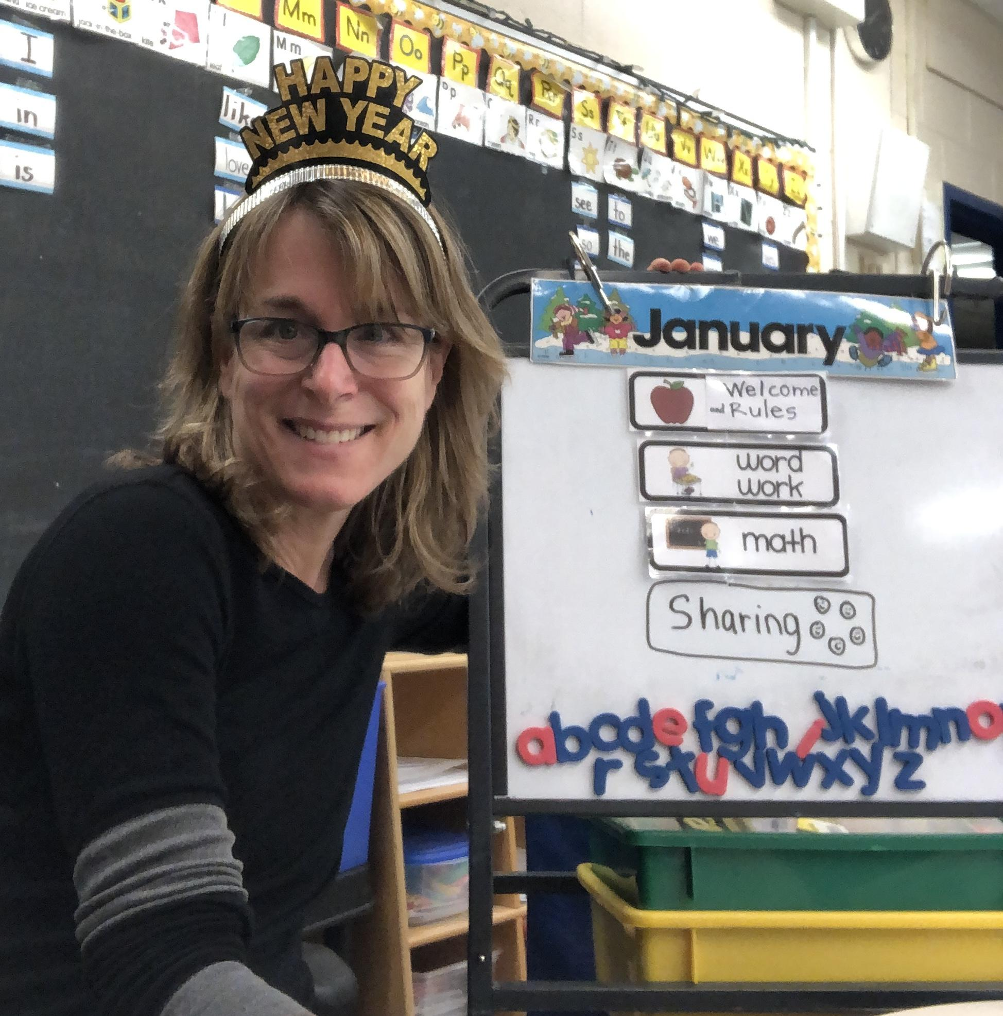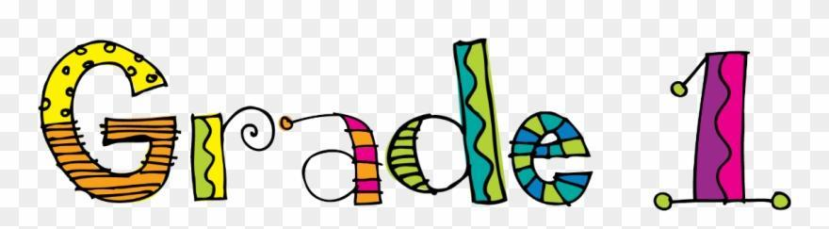
Home Learning Mrs. Gladwin
Daily work: All students have a learning packet with activities for the week. Daily work can be completed at students’ own pace throughout the day. You may use the video links included below to engage your child.
Online Learning: Our class will be online daily from 9am-10am via google meet. A link for the meet will be sent to parents’ home email addresses. I realize that parent work schedules and/or daycare may prevent students from being able to join. That’s ok.
Reading Online: Each Student has a login for RAZ plus (included in learning packet) https://www.raz-plus.com/
Additional Support: I am open to connecting outside of our online 9am-10am hour with phone calls or video chats. We are working a regular school day so please reach out if you need to.
Mrs. Gladwin

Email: chriglad@gnspes.ca
Monday, January 10, 2022
Language Arts:
- What do you know about the month of January? Listen to the January Song: https://www.youtube.com/watch?v=GlAcfsgv-fE
- January Rainbow Printing: print January in different colours.
- January Wordsearch: Read the words and complete the wordsearch
- January Poem: Read the new poem on the front of your work folder. Print your name and colour.
- Read from your online RAZ kids. Your code is in your learning packet. https://www.raz-plus.com/

Math:
- Fill in the missing numbers in your January calendar. Colour your calendar.
- Find today’s date on your calendar and colour in the weather. yellow-sunny, grey-cloudy, blue-raining, white-snowing
- Add 67 to days in school chart.
- Practice saying the months of the year in order.
Jack Hartman Month song:
https://www.youtube.com/watch?v=SSl-SbVz2o

Tuesday, January 11, 2022
Language Arts:
- Printing Sheet - practice printing c o a d g q. Complete the printing page.
- Word Wall Words: Cut out each word from each strip of word wall words. Read them quickly. Save them. We will use them tomorrow.
- Writing: Draw and write one or two sentences about something you would like to share on the writing page.
Remember sentences start with a capital letter and end with a . ! or ? Warm up with the Sentence Song: https://www.youtube.com/watch?v=0Wrv_ZviMEc
- Read from your online RAZ kids. Your code is in your learning packet. https://www.raz-plus.com/
Math:
- Calendar: Colour in the weather for today’s date and add 68 to days in school chart.
- Teen Number Warm Up Songs: https://www.youtube.com/watch?v=psSWYxlnob4
https://www.youtube.com/watch?v=1W5aYi3lkho
- Review the teen numbers by filling in the missing numbers on each number line.

Wednesday, January 12, 2022
Language Arts:
- Printing Sheet - practice printing r n m u. Complete the printing page.
2. Word Wall Words: Find different ways to sort your word cards (Example: words that start the same, or end the same, or words that have the same letter, or words with the same amount of letters)
Can you guess how I sorted my words?
my yes by you | me be come can the to of a I in will is that it and no went

3. Writing: Winter: On the winter writing page, draw a picture and write a sentence about you like about winter or something you know about winter.
Winter video: Brr! 5 Videos about Winter!
https://www.youtube.com/watch?v=jwdkg5eFaHs
4. Read from your online RAZ kids. Your code is in your learning packet. https://www.raz-plus.com/
Math:
- Calendar: Colour in the weather for today’s date and add 69 to days in school chart.
- Warm Up: watch the video and say the number you see.
https://www.youtube.com/watch?v=4LAXV534JyQ
- Teen number Sheet: Read or count each square. Match the number to the colour at the top and colour the square.

Thursday, January, 13, 2022
Language Arts:
- Printing: practice printing i j p. Complete the printing page.
- Complete the word wall words word search puzzle.
- Read from your online RAZ kids. Your code is in your learning packet. https://www.raz-plus.com/
Math:
1. Calendar: Colour in the weather for today’s date and add 70 to days in school chart.
2. Warm Up: Count to 30 and backwards from 30.
Song: https://www.youtube.com/watch?v=cwcCyXsGN7E
3. Complete the number sheet by completing the forward and backward counting. Read each number word and print the number.

Friday, January 14, 2022
Language Arts:
- Printing Sheet: practice printing l t h b k f. Complete the printing page.
- Complete the back of yesterdays word wall wordsearch page. Read each sentence and use one of the words to make it make sense.
- Read from your online RAZ kids. Your code is in your learning packet. https://www.raz-plus.com/

Math:
- Calendar: Colour in the weather for today’s date and add 71 to days in school chart.
- Warm Up: Counting to 30 and backwards Song: https://www.youtube.com/watch?v=WHuuuh9GgP8
- Complete the number maze by drawing a line from number to number in counting order. On the back have a grown up say random numbers 20-29 for you to print neatly and quickly.

HAPPY WEEKEND! I am looking forward to seeing everyone back at school next week!

