Dear Students and Parents,

Welcome to the Grade One At Home Learning Newsletter. In this newsletter you will find activities you can do at home to support your child’s learning while we are away from school. These activities should take about an hour to do each day, and can be done in chunks. None of the activities requires you to have a printer. All you will require each day is some paper, a pencil, and some colouring things if you have them. These activities are meant to keep your child learning and connected to school. They should not be stressful. If at any time you are feeling overwhelmed, please reach out. We are here to help.

Sincerely,
Mrs. Robar (crobar@gnspes.ca )
Ms. Lawlor (klawlor@gnspes.ca)

Google Meet Classroom Rules

I am learning from home on Google Meet.

When I am learning from home there are certain classroom expectations just like when I am at school.

I will follow my schedule as I do when I am at school in person.

I will log onto the Google Meet that my teachers set up.
This is just like being in the classroom.

I will follow rules when working from home as I do when I am in person at school.

My Google Meets Rules are:
- When my teacher starts to teach I will turn off my microphone.
- When my teacher is teaching I will pay attention.
- When my teacher is teaching I will only ask a question that is related to the topic being taught.
- When my teacher is teaching it is NOT a time to talk or use the chat with others in the class. This means NO talking and NO typing.
- When my teacher is teaching I will NOT interrupt.
When I follow these rules I get to stay in the Google Meet, learn and see my teacher and classmates!

I will try my best to pay attention and not interrupt my teacher when meeting on Google Meet.
Grade One At Home Learning
January 10 - 14
Mrs.Robar/Ms. Lawlor
Google Meet link for our daily meetings from 10:00-11:00
Monday, Tuesday, Wednesday, Friday meet.google.com/hbe-igim-xgx
Thursday meet.google.com/ktr-wjhj-mpz

Mrs. Robar crobar@gnspes.ca /Ms. Lawlor klawlor@gnspes.ca

Well Being:
Remember: We are not working from home, we are at home, during a crisis, trying to work. As educators, we are expected to plan an hour a day of work for students and an hour online session. As parents you have the flexibility to use this work in the way that works best for your families. We encourage families to put well-being ahead of any other activities.
There is a well-being link on our BES Learning from home website, as well as Music and Phys Ed. Follow this link to access it: http://besdistancelearning.weebly.com/

Completed work: Please keep all completed work and return it to school on Monday, January 1
Monday, January 10

Reading - Read for 20 minutes using your Raz-Kids account (Instructions can be found at the bottom of this document) Students should select a book to listen to, read, and then answer questions. Raz- Rocket/Robot use in the Star Zone is only for extra play after work is completed.

Word Study - “an” Word Family Watch the video about the “an” family (https://www.youtube.com/watch?v=ei3dsyr8A20)
Write the word an at the top of a piece of paper. Under that write as many words you can think of that are in the “an” word family. Example: can If you can think of 10 or more you are a WOW.

Writing - Write three sentences using words from your “an” word family list. Remember that a sentence must start with a capital, end with punctuation, and make sense.

Math - Write your birthday at the top of a piece of paper. A parent can write it first for you to copy if you need help.
Skip Counting - Practice skip counting out loud by 10 to 100 (10, 20, 30, 40, 50, 60, 70, 80, 90, 100) and by 2 to 20 (2, 4, 6, 8, 10, 12, 14, 16, 18, 20)

Representing and Partitioning Teen Numbers - Write the number 11 on paper. Show 4 ways that you could represent the number (show it in different ways). Make sure one of your ways shows it using partitioning (breaking it into

Tuesday, January 11

Reading - Read for 15 Minutes from Raz-Kids. Listen to, read and answer questions. For one of your books read it out loud to someone at home. At the end tell them who the characters were in your story.

Word Study - Look at the sheet below and say the name of each picture. Write the words that are in the “an” family.
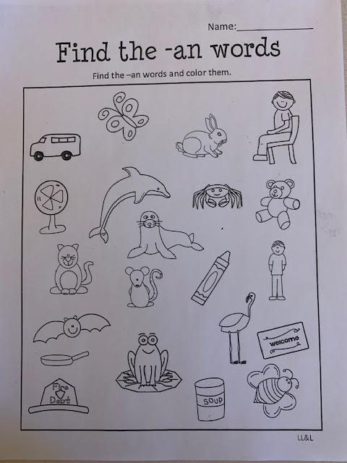

Writing - All About - Pick a toy or item that you got for Christmas. Write and tell me all about it. Remember to start with a title and then describe what your toy looks like, sounds, like, how you use it, who gave it to you, and why you like it. Try to think of lots of details you can write about it. Try to write 4 or more sentences to be a WOW.

Math - Writing numbers to 100. Today is a big counting and writing day. On a piece of paper write the numbers from 1 to 100. Start at 1 and when you get to 10 go down to the next line for 11 and so on. When you are done it should be nice and neat and look like a 100 chart.
Wednesday, January 12

Reading - Read for 20 minutes using your Raz-Kids account. Students should select a book to listen to, read, and then answer questions. Raz- Rocket/Robot use in the Star Zone is only for extra play after work is completed.

Word Study -Use the picture below to help you. You can make your own chart on paper or make two lists. Sort the picture words into the “an” family and the “at” family.
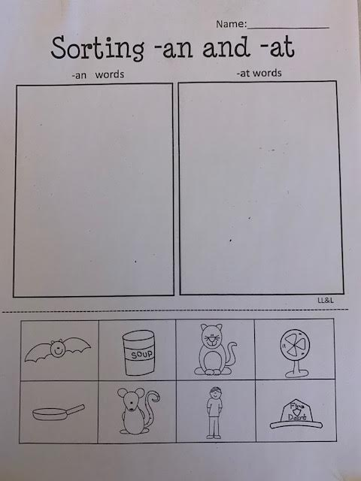

Writing - Look at the two sentence below. I have made a lot of mistakes. Try to find all my mistakes and then write the sentences correctly.
- today is A gReat Day to go Outside and going foR a Walk
- i like To Eat pizzA with Bacon aNd pepperoni

Math - Counting Backwards from 100.
Watch the counting backwards video (https://www.youtube.com/watch?v=8jMmZaFvRpE)
Practice counting backwards from 100 out loud to someone at home.

Skip counting - Write the numbers you say when you count by 10 on a piece of paper.
Write the numbers you say when you count by 2 on that paper too.
Thursday, January 13

Reading - Read for 15 Minutes from Raz-Kids. Listen to, read and answer questions. Draw a picture that tells me about one of the stories that you read.

Writing - I love to go on winter walks in the woods. What is your favourite winter activity? Remember that Grade One’s write 4 or more sentences that are neat, have capitals and periods, and make sense. I am so excited to read your awesome writing!

Math - Where can you find patterns at home? See how many examples of patterns you can find. Draw, write, or snap pictures of where you found patterns. Pictures can be sent to klawlor@gnspes.ca
Friday, January 14
Reading - Today pick one book on Raz-Kids to listen to, read, and answer questions for. You can use the rest of the time today to go to the Star Zone.

Writing - Write a letter to Mrs. Robar (Friday Letter) Write and tell her about something you did during your Winter Break. Remember that Grade One’s write 4 or more sentences that are neat, have capitals and periods, and make sense. I can’t wait to read your letter and write back to you.

Math - Skip Counting by 5
Watch the skip counting video (https://www.youtube.com/watch?v=EemjeA2Djjw)
Practice counting by 5 to 100 outloud.
You can look here if you need some help.
5 10 15 20 25 30 35 40 45 50 55 60 65 70 75 80 85 90 95 100
Game: Go to www.abcya.com. Click on Grade One, then Numbers. Find the game called Number Chart. Do the beginner level and then try the challenge.

Mindfulness:
First Listen to this video with your eyes closed. (https://www.youtube.com/watch?v=DCirAu07TC8).
Next, draw a picture of what you imagine the sea child looks like inside their bubble.
Then watch the video to compare how your sea child looked with the video.

Raz-Kids - An online reading program for kids.

Hi Parents and Students,

All students in my class have a Raz-Kids account where they can listen to, read, and answer questions about book at their Just Right reading level. They earn points for doing each activity, and can use those points to do some fun activities in their “Star Zone”.
Here’s how to access your Raz-Kids account.
- Go to www.raz-kids.com
- Click on the green “kids Login” button.
- enter your teacher’s username (crobar0)
- Find and click on your name in the group.
- Click on your password. (It’s the apple)
- Click on the “Level Up” space station to access your books.
- Now you are ready to listen to, then read, then answer questions about your books. Just click on the icons under each book. When you have finished all the tasks at this level it will put you in the next level.
- When you have earned lots of points (and your parents say it’s time to have some fun) you can click on the “Star Zone” icon at the bottom of the main screen. If you’re in your “Level Up” space station you will have to click the green arrow on the top of the page that says “Back to Reading”. When you’re in the “Star Zone” you can use your points to build an avatar or decorate your rocket. Have fun!

