Week 4 At-Home Learning
On-line Meets are weekdays 10:00-11:00 am.

May 23, 2021
Dear Parents:

Welcome to Week 4 of At-Home Learning!
Please note that Monday, May 24 is Victoria Day, which is a holiday, so there will be no on-line learning or Homework that day.

Our special day this week will be :
- Show and Tell a Human Day on Friday, May 28.
This can be any human that lives in your house. Both
the student and the family member should each tell 3 things about the family member.
For example: First, the student will introduce their person and tell 3 things about them. Then the guest will tell 3 things about themself. Interesting things to tell may include: what are their likes and dislikes, favourite sport/tv show/food/colour, what the adult does for a hobby, for a job, etc.

*Remember to email us a photo of your child’s work, IF it is written in orange and underlined.*

*As always, if you have any questions, please contact your child’s teacher:*

pconklin@gnspes.ca OR ksylvester@gnspes.ca

Thank you and stay safe!

Patti Conklin and Kelly Sylvester

Just a reminder: The government has announced that they will be extending on-line learning until the end of the school year.

Tuesday, May 25, 2021

Reading:
Read fiction from a book or Raz Kids for 20 minutes.

Writing:
Answer the following questions about the fiction book that you read. *Print the answers on a piece of paper and email it to us, please.*
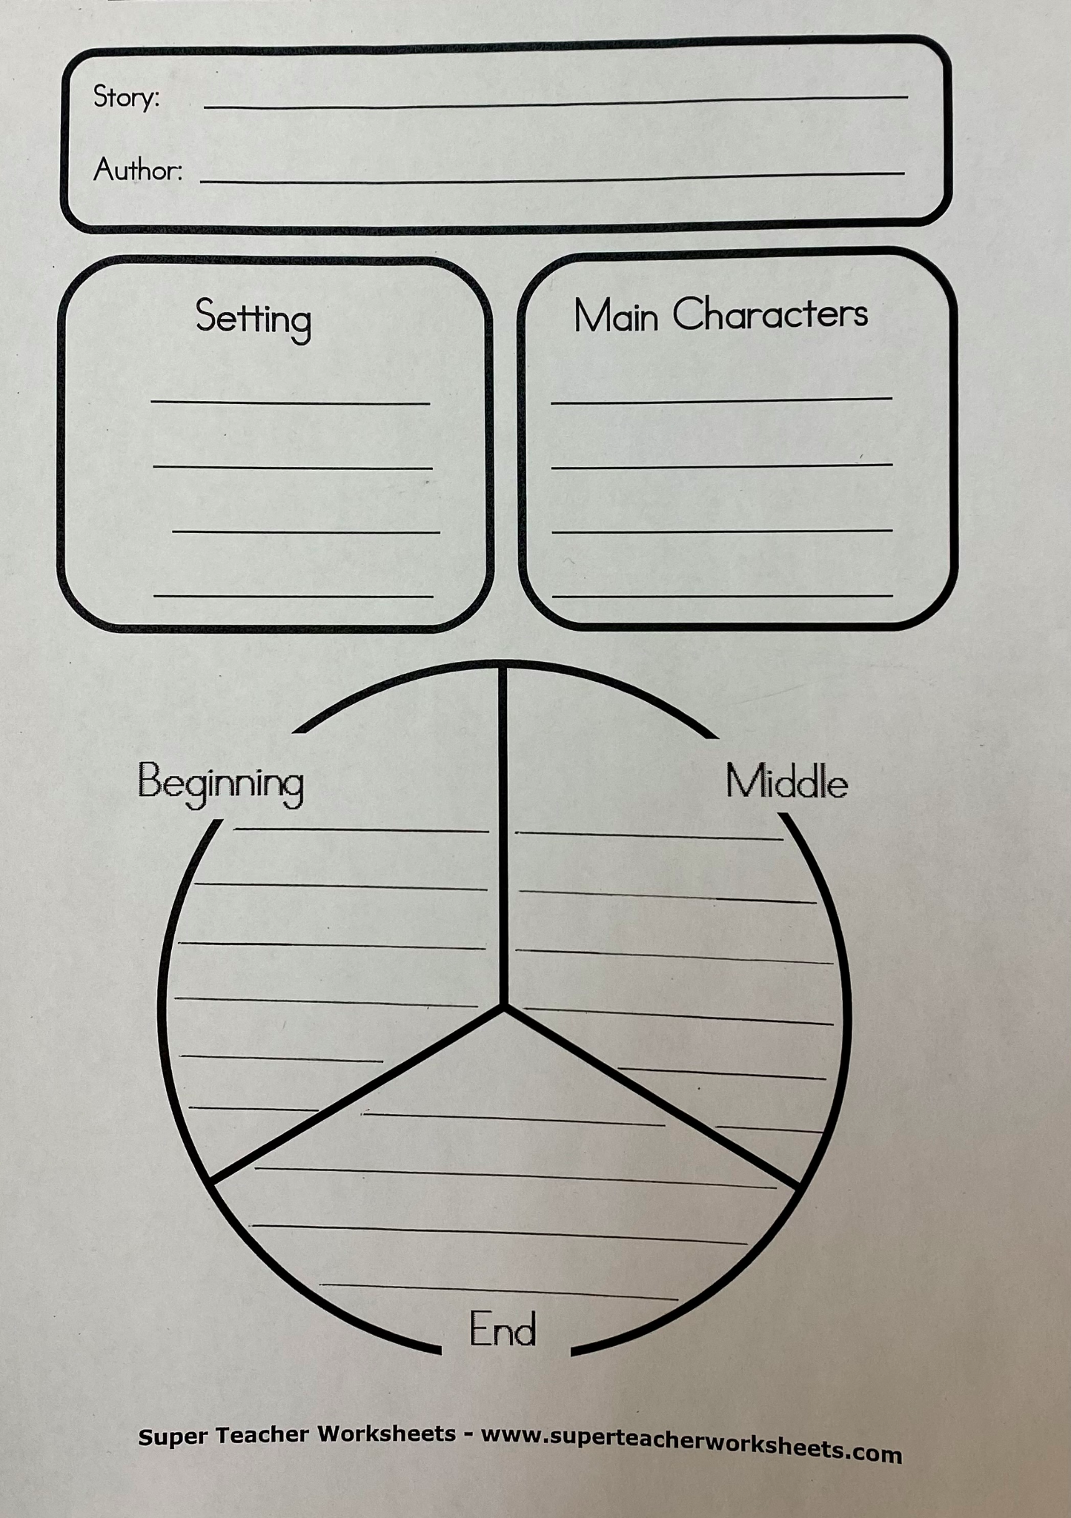Math:

1.Today in math we are going to be exploring what different 2D shapes make up the faces of 3D shapes. Watch the following video:
Faces of 3D Shapes | Geometry | Math for 2nd Grade | Kids Academy

2.On paper, print the name of each 3D shape for the objects below. *Take a photo and email it to your teacher.*
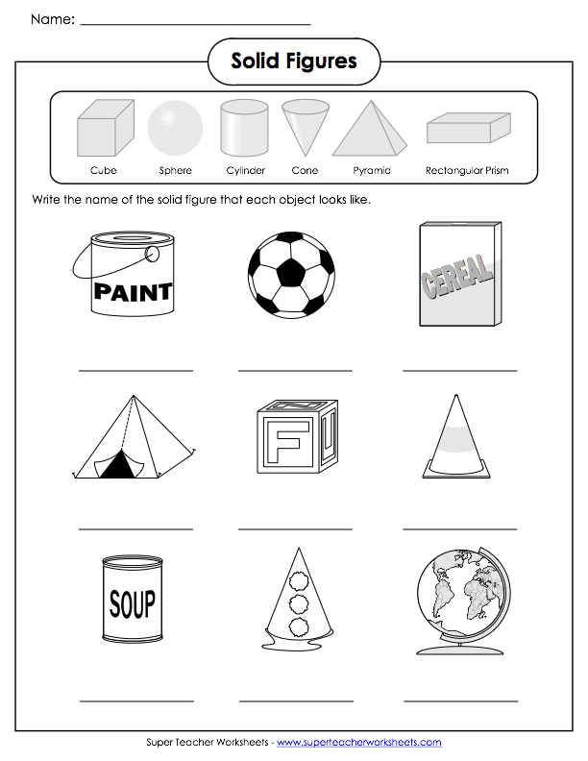

Extra challenges board

Choose an activity every day from the Challenge Board. Enjoy and have fun!

Skip outside! | Do A KRC Video  https://www.youtube.com/watch?v=bXe_RfngFF0 | Help do a household chore!
Draw and colour a Spring picture! | Help make supper! | Make a list of all of your favourite things!  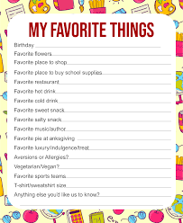
Art  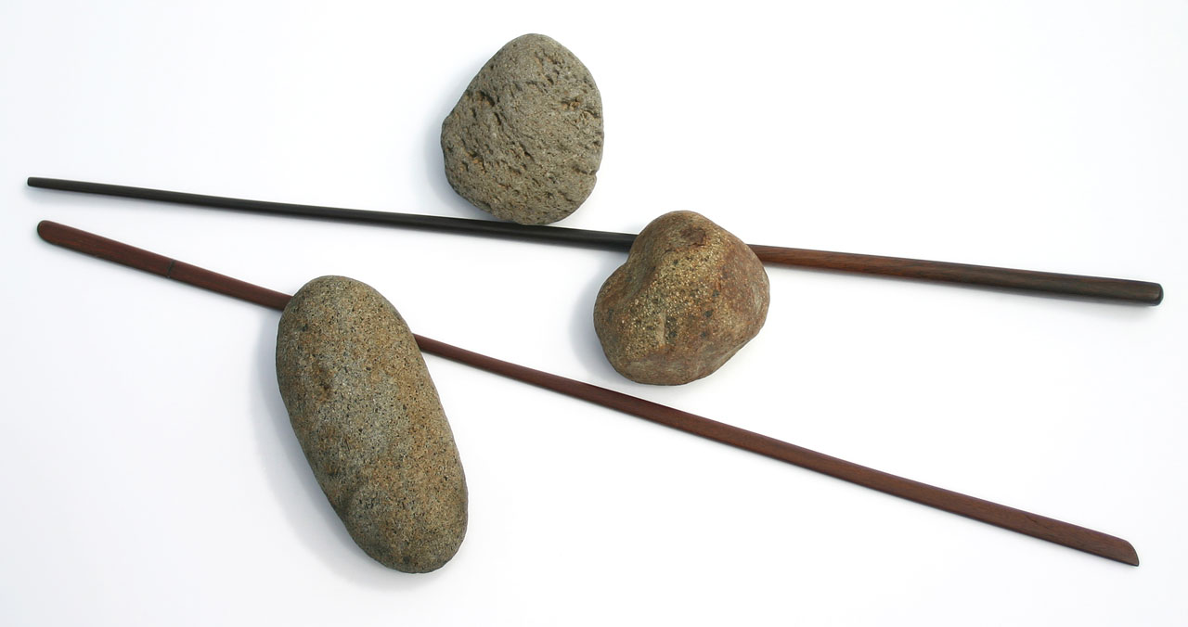  Make a craft. | Sky Watch  Star gaze! | Have a scavenger hunt!  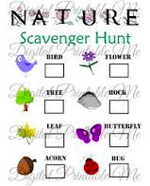

Wednesday, May 26, 2021

1.Listening/Reading:
Watch and listen to the following story online:
https://www.youtube.com/watch?v=g3d2N6pWcw0
Think of reasons you could use to persuade your parents into getting you a pet.

2.Writing/Word Study:
Click on this link:
Practice Writing a Persuasive Opinion Paragraph

Below you will see 2 letters, with Luke and Lucy each writing letters to their parents to ask for a new pet dog. Can you tell which letter is more persuasive?

*Write a persuasive letter to your parents asking for a special pet that you would love to have. Your goal is to be persuasive! Email us a photo of your letter.*

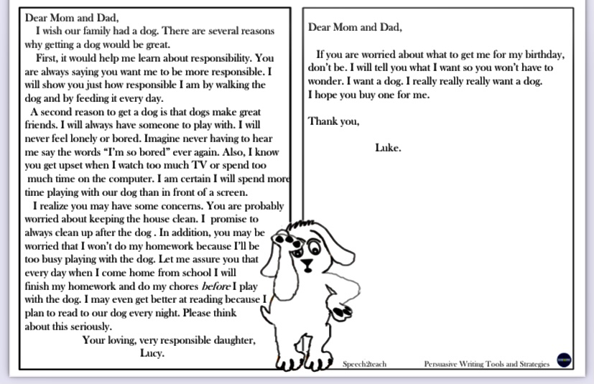

Math:
Word Problem Wednesday - Addition and Subtraction
*Please take a photo of your word problems and email it to the teacher. Please show your work using an open-ended numberline, an equation and a Part-Part-Whole chart!*

- There are 68 bananas at the grocery store. 35 of the bananas are not ripe, but the rest are ready to eat. How many bananas are ripe?

- I had 99 stickers. A friend gives me 100 stickers. How many stickers do I have now?

- Susie had 21 friends in Grade 2. In Grade 3, she makes 25 new friends. How many friends does she have altogether?

- Jack had 75 HotWheels. Eric had 50 HotWheels. How many more HotWheels does Jack have than Eric?

- Jane and her brother Sam had a yard sale. They made $400. They split the money equally. How much money did they each get?

Extra challenges board: Choose an activity every day from the Challenge Board. Enjoy and have fun!

Skip outside! | Do A KRC Video  https://www.youtube.com/watch?v=bXe_RfngFF0 | Help do a household chore!
Draw and colour a Spring picture! | Help make supper! | Make a list of all of your favourite things!
Art  Make a craft. | Sky Watch  Star gaze! | Have a scavenger hunt!
Thursday, May 27, 2021

Reading/Comprehension:
1. Today you will be doing another Read Works reading passage with comprehension questions.
I have assigned a reading titled “Life of a Butterfly”, available from May 24-30. Please read the passage and answer the related questions on the Read Works site.
First: go to www.readworks.org/student
Next: Type in your class code-
Mrs. Conklin’s class : PLFY42
Mrs. Sylvester’s class : ZMY55M
Then: Click on your name.
After that: Type in the password-
1234 (same password for both classes)
Finally: Read or listen to the passage and then answer the questions.

Word Study:
An adjective is a word that describes a noun. Watch the following video to learn more about adjectives:
https://www.youtube.com/watch?v=-NqnQJjDmB0

Read the sentences below and look for the adjective and noun in each sentence. On a piece of paper, print the adjective and noun for each sentence. Circle the adjective and underline the noun. Example: Print “right foot”- right is the adjective, so circle it. Foot is the noun, so underline it.
*Take a photo and send it to your teacher.*
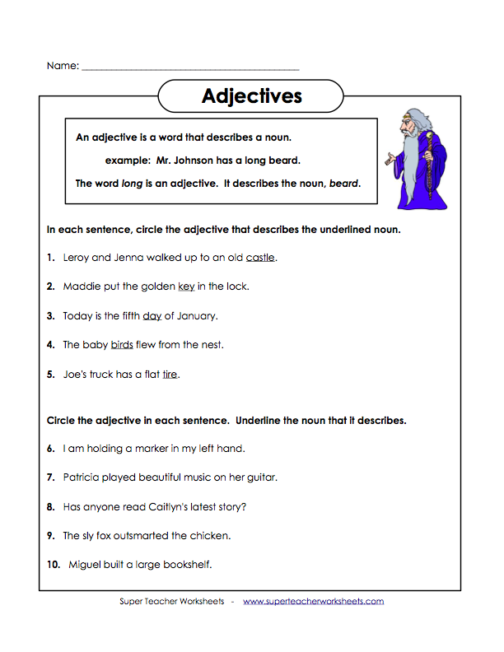

Math: 3D Objects in Real Life

1. Answer the below questions on a piece of paper. *Take a picture and email it to your teacher.*
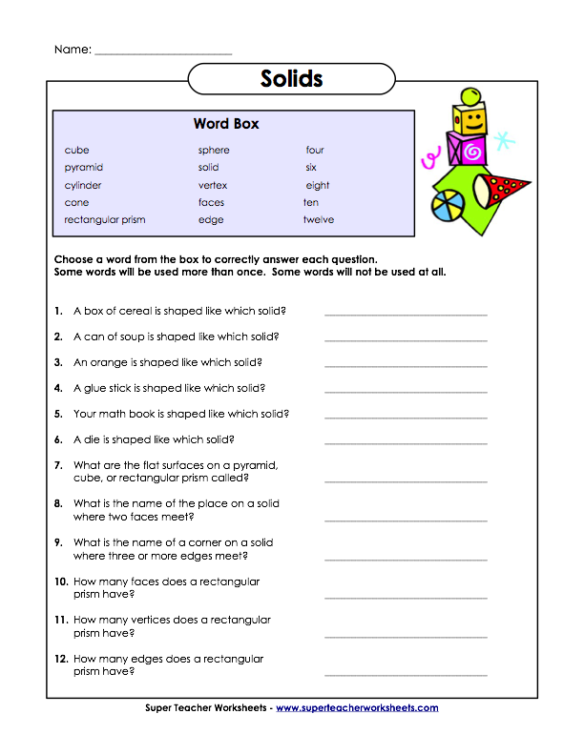

Extra Challenges Board
Choose an activity every day from the Challenge Board. Enjoy and have fun!

Skip outside! | Do A KRC Video  https://www.youtube.com/watch?v=bXe_RfngFF0 | Help do a household chore!
Draw and colour a Spring picture! | Help make supper! | Make a list of all of your favourite things!
Art  Make a craft. | Sky Watch  Star gaze! | Have a scavenger hunt!

Friday, May 28, 2021

Reading:
1.Read 20 minutes of fiction or non-fiction from a book or Raz-Kids.

Word Study:
1.We learned that an adjective is a word that describes a noun (a person, place or thing). Today you are going to hunt for adjectives and nouns in sentences. Watch the following video:

https://www.youtube.com/watch?v=hifcUYaACzI

*Copy the following sheet onto a piece of paper. Make sure you print the adjective and the noun it describes. Email us a photo of your work*.
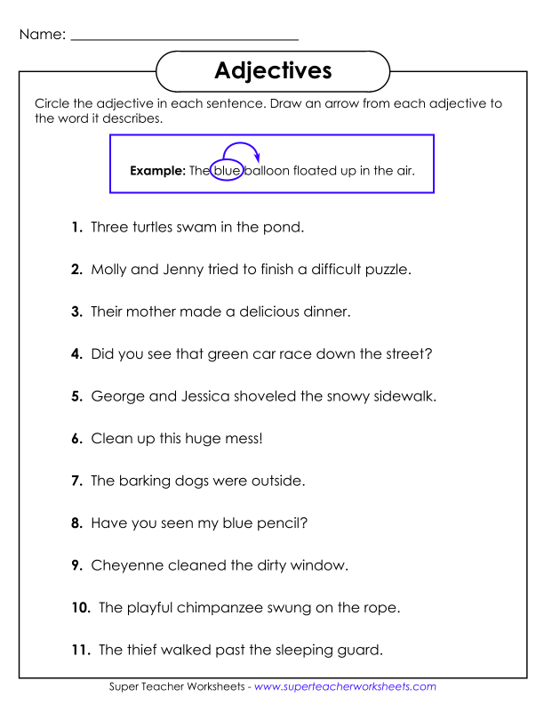

Math: Comparing 3D Shapes

1. Today we are going to be comparing 3D shapes.
When comparing 3D shapes, it is important to practice using math words like: face, edge, vertices, roll, stack, slide. Watch the following videos on comparing 3D shapes:
https://www.youtube.com/watch?v=gP6OJdHTRes

2.Copy the following chart on a piece of paper for Sorting Rule #1 listed below. You may choose from these shapes for sorting: cube, sphere, rectangular prism, triangular prism, pyramid, cylinder, cone. Print some of the shapes in the columns, according to the sorting rule.
Do the same thing for Sorting Rules # 2, 3, 4, which are listed below.
*Take a photo of this Math and email it to the teacher.*
Sorting Rule #1:  Square faces | Not Square Faces

Sorting Rules
#1 Square faces versus not square faces
#2 Shapes that roll versus shapes that slide
#3 Shapes with 6 faces vs shapes with less than 6 faces
#4 Shapes with 8 vertices vs shapes with less than 8 vertices
Extra Challenges Board
Choose an activity every day from the Challenge Board. Enjoy and have fun!

Skip outside! | Do A KRC Video  https://www.youtube.com/watch?v=bXe_RfngFF0 | Help do a household chore!
Draw and colour a Spring picture! | Help make supper! | Make a list of all of your favourite things!
Art  Make a craft. | Sky Watch  Star gaze! | Have a scavenger hunt!

