Google Meet Classroom Rules
I am learning from home on Google Meet.

When I am learning from home there are certain classroom expectations just like when I am at school.

I will follow my schedule as I do when I am at school in person.

I will log onto the Google Meet that my teachers set up.
This is just like being in the classroom.

I will follow rules when working from home as I do when I am in person at school.

My Google Meets Rules are:

- When my teacher starts to teach I will turn off my microphone.
- When my teacher is teaching I will pay attention.
- When my teacher is teaching I will only ask a question that is related to the topic being taught.

- When my teacher is teaching it is NOT a time to talk or use the chat with others in the class. This means NO talking and NO typing.
- When my teacher is teaching I will NOT interrupt.

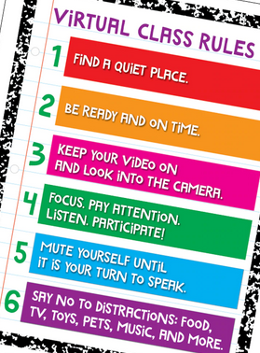
When I follow these rules I get to stay in the Google Meet, learn and see my teacher and classmates!

I will try my best to pay attention and not interrupt my teacher when meeting on Google Meet.

