Monday, January 10 – 14, 2022 3 Wamboldt
Language Arts
20 minutes of reading each day-- books that you have at home or choose a story from on-line site Tumblebooks (login: bridgewater, password: books)
1) Watch: Penguins Make Bad Pirates https://www.youtube.com/watch?v=usMEVqz4CrU
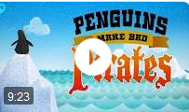 Complete comprehension questions for this video
2) Find your pirate name and draw a pirate penguin sheet.
3) Read Aloud: How I Became a Pirate (Tumblebooks)
Complete comprehension questions
4) Read Aloud: Pirates Don’t Change Diapers (Tumblebooks)
5) Sword Training/A Big Storm/Swab the Deck/Climb the Crow’s Nest comprehension passages and miscellaneous activities on the back
6) Follow 1-2 step directions pirate picture
7) Pirate Word Ladders
8) I Want to be a Pirate poem
9) Non-fiction passage about Parrots/questions
10) Fiction story about parrots: Polly Parrot Picks a Pirate, Story Train Read Aloud (https://www.youtube.com/watch?v=ZwEHeNyfEsQ)
10) Meredith’s Voyage writing
11) Pirate prompt writing
Math
1) Math mystery
2) Mystery numbers

Ahoy! | Hello! |  | Jolly Roger | Flag of a pirate ship
Aye! | Yes |  | Avast ye | Pay attention
Matey | Shipmate/Friend |  | All hands hoay | Everyone get on the deck
Lass | Girl |  | Marooned | To get stuck on a desert island
Avast! | Stop |  | Weigh anchor | Get the ship ready to sail
Blimey! | Something to say when frustrated |  | Doubloons | Gold coins or money
Shiver me timbers! | Something to say when surprised |  | Shanty | Song
Yo-ho-ho! | Something to say when you are happy |  | Lad | Young man
Ye | Use this instead of “you” |  | Starboard | Right side of the ship
Buccaneer | Another name for pirate |  | Port | Left side of the ship
Pirates say “Arrrrr!” a lot and replace “my” with “me” in sentences.

Penguins Make Bad Pirates comprehension questions:
1. The pirate ship was stuck between two icebergs in the:
a) Arctic Ocean b) Antarctic Ocean c) LaHave River

2. Captain Crab Legs’ crew abandoned ship, calling him a frozen headed:
a) rabbit-brain b) turtle-brain c) parrot-brain

3. Captain Crab Legs liked to steal treasure and:
a) toosie pops b) lollypops c) jawbreakers

4. The name of the penguin that became first mate:
a) Gerry b) Terry c) Perry

5. Penguins would rather play than work so they were:
a) swinging from the ropes
b) skating on ice cubes around the ship
c) making funny clothes
d) all of the above

6. What was Captain Crab Legs’ favourite flavor of snow cone?
a) blueberry b) lemon c) pickle

7. What didn’t Captain Crab Legs see during his voyage?
a) icebergs b) snow c) polar bears
8. Of the flavours offered, which one would be your favourite? _________
9. Match the pirate words/phrases to English. (Check pirate dictionary.)
Pirate words/phrases | Letter | English
1. matey |  | a) yes
2. buccanner |  | b) you are surprised
3. baton down the hatches |  | c) you are happy
4. jolly roger |  | d) song
5. shiver-me-timbers |  | e) another name for pirate
6. aye |  | f) prepare for trouble
7. shanty |  | g) shipmate or friend
8. yo-ho-ho |  | h) flag of a pirate ship

Find your pirate name (You can just choose whatever name you would like.)

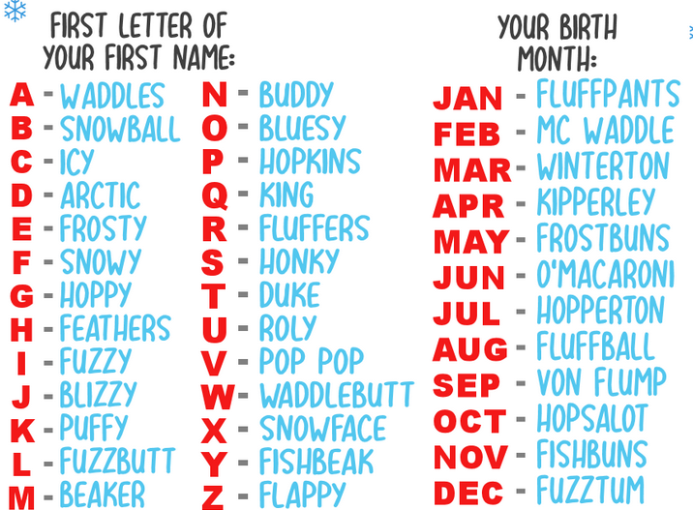
Draw a penguin and then add pirate accessories.

How I Became a Pirate (Google Tumblebooks or on BES website)
(login: bridgewater, password: books)

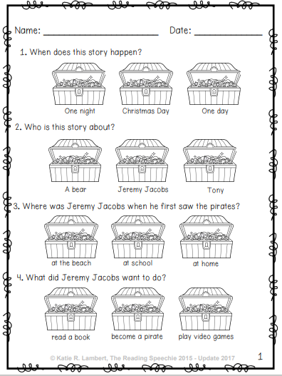

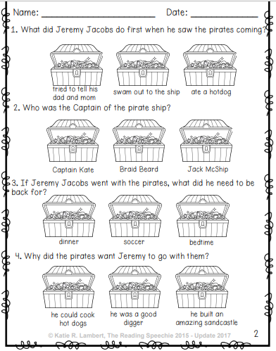

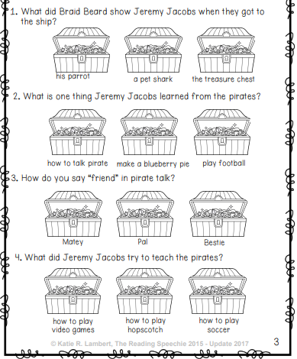

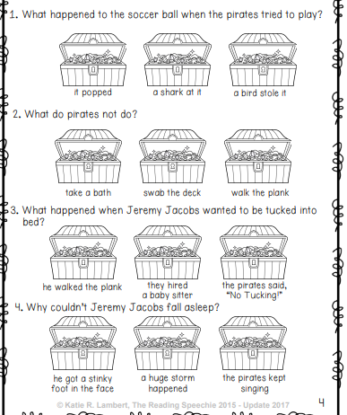

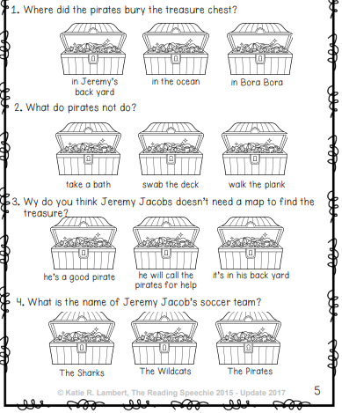

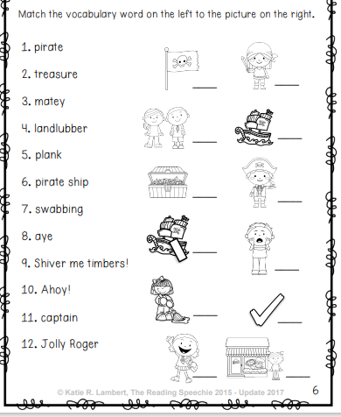

Pirates Don’t Change Diapers
(Tumblebooks: login: bridgewater password: books

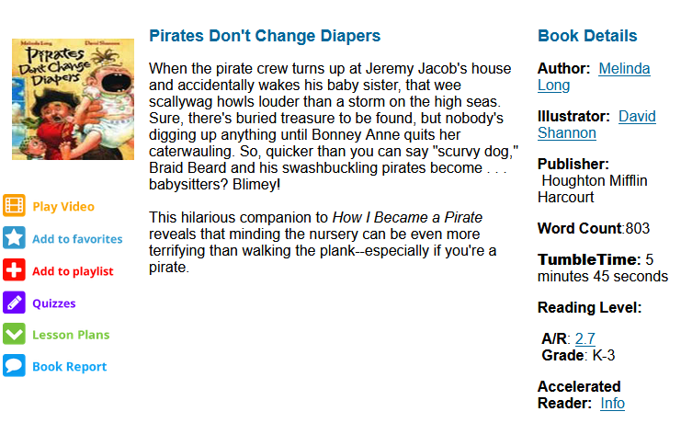

(Paper package contains personalized stories.)
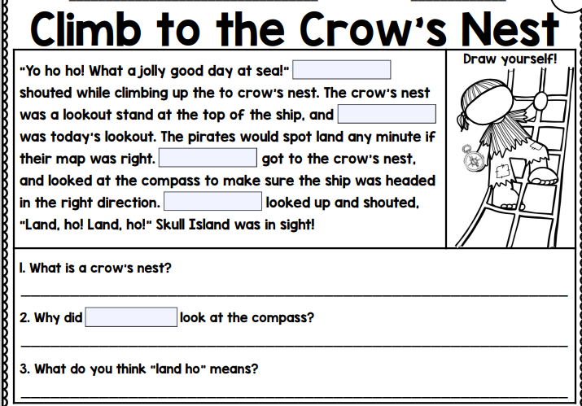
Pirate Yoga
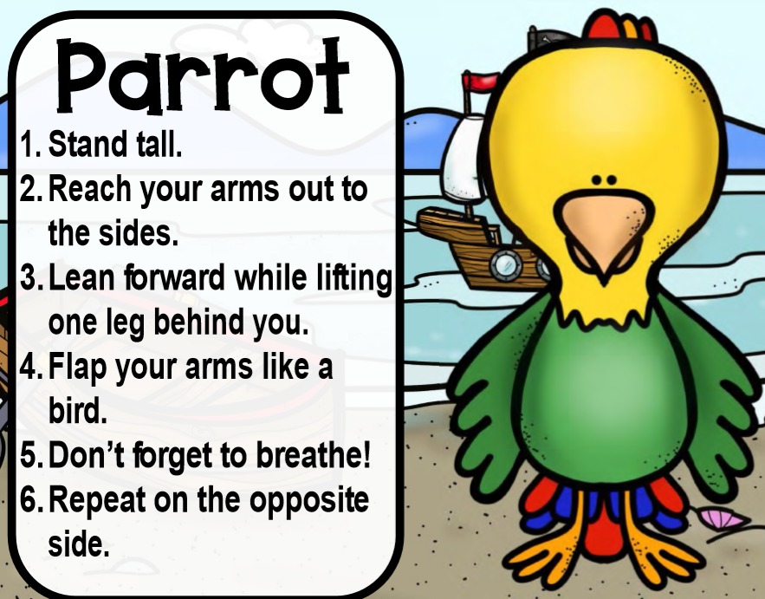 | 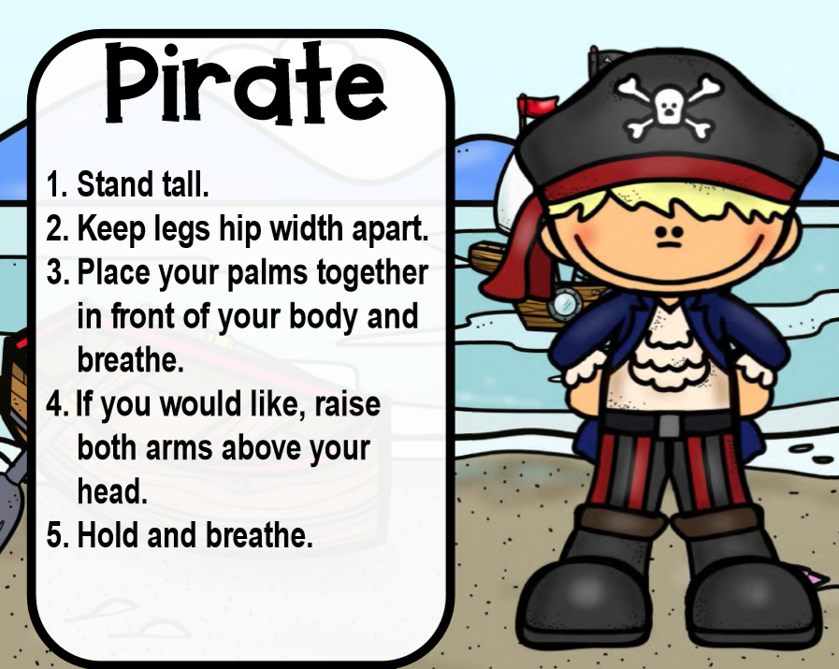
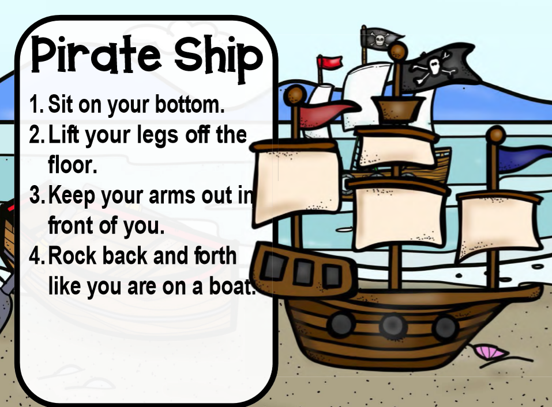 | 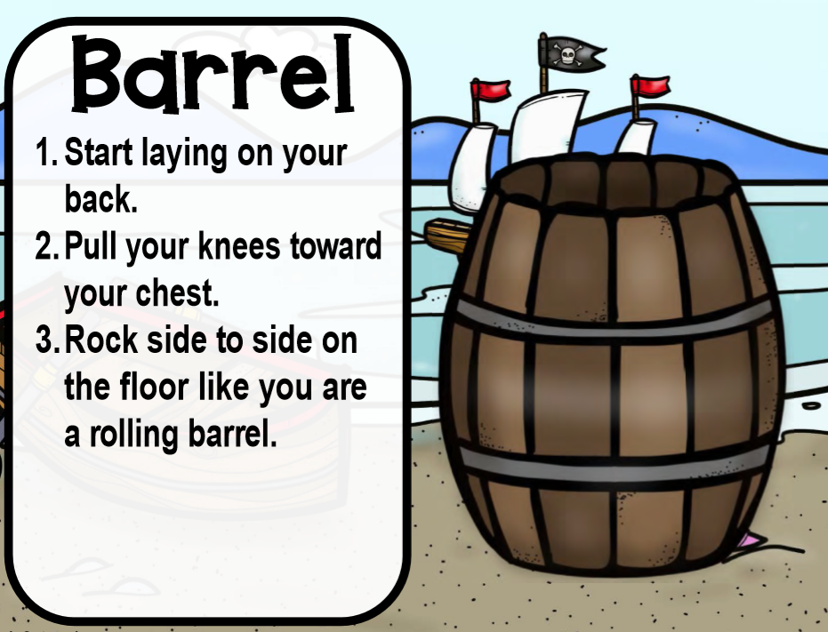
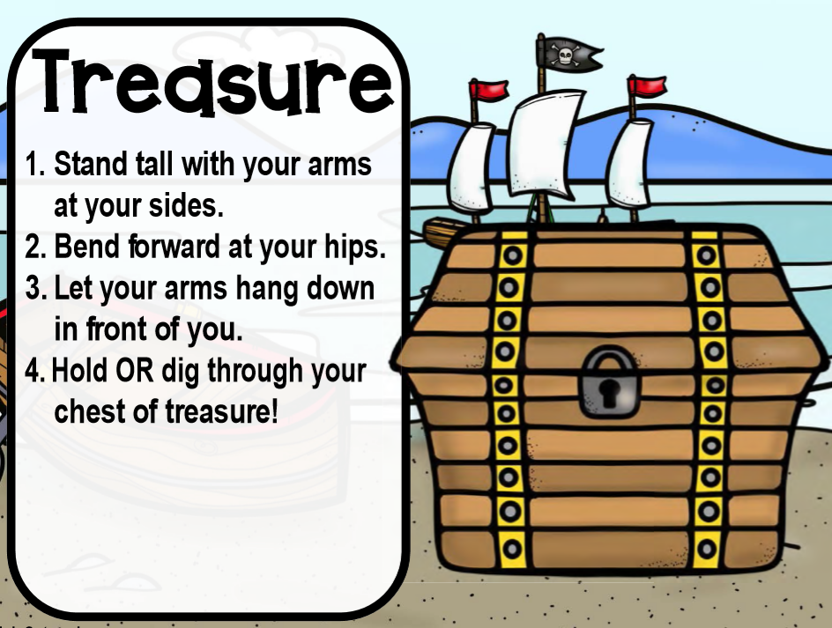 | 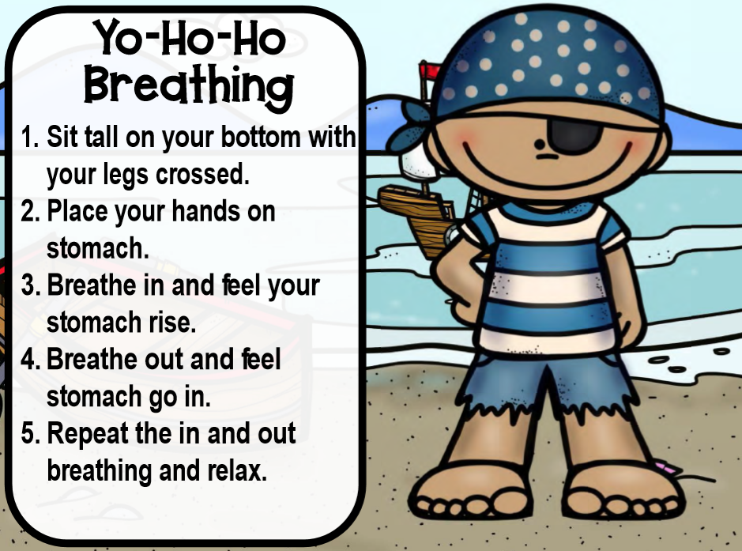

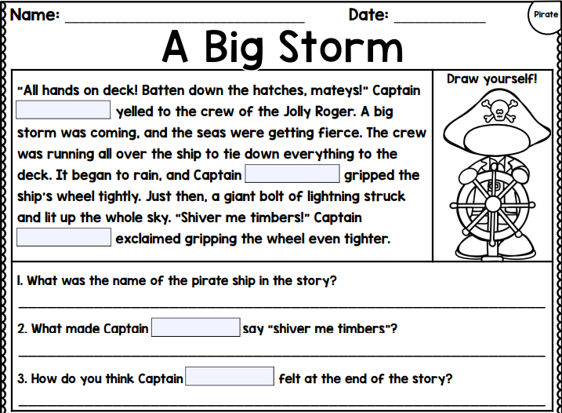

Foxy Beard maze: There are three ways to start for the secret island where Foxybeard keeps his treasure, but only one of them will take you there! Follow the maze by tracing each route with a pencil, and you will see which way Foxybeard went when he wanted to hide his gold moidores.
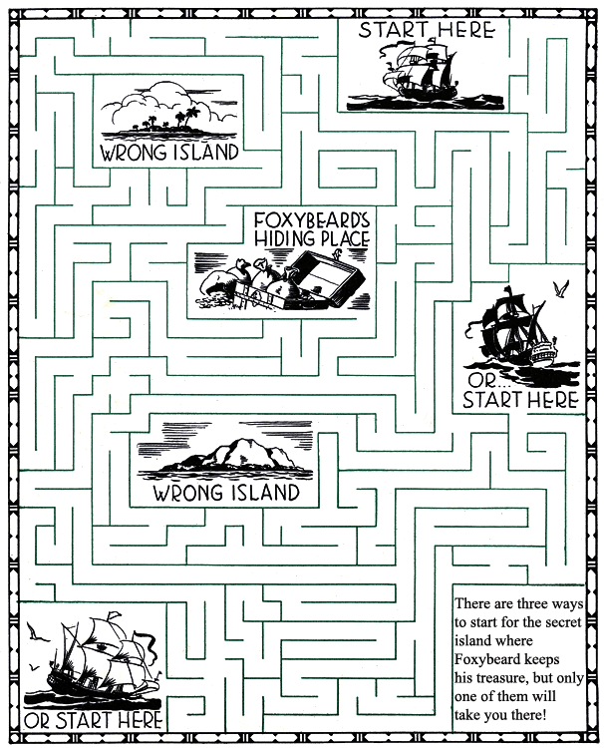
Foxybeard was a pirate bold,
On a certain island he hid his gold.
He hid his gold, but never fear,
We'll find that gold if gold is here.

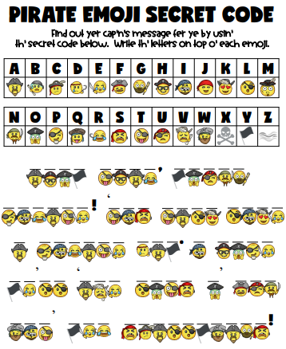

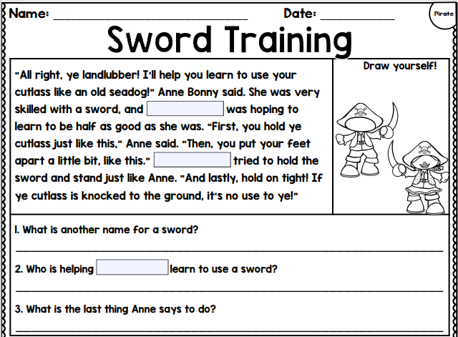

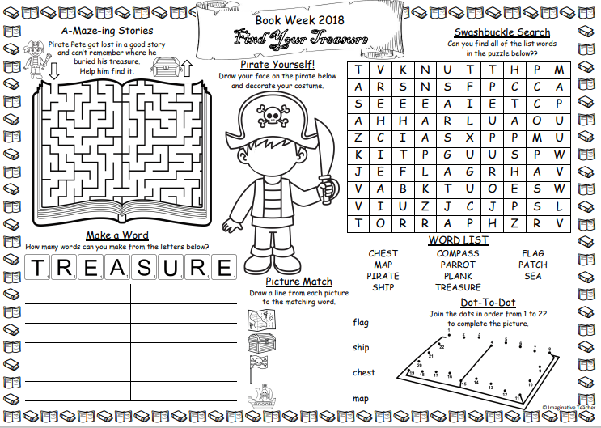

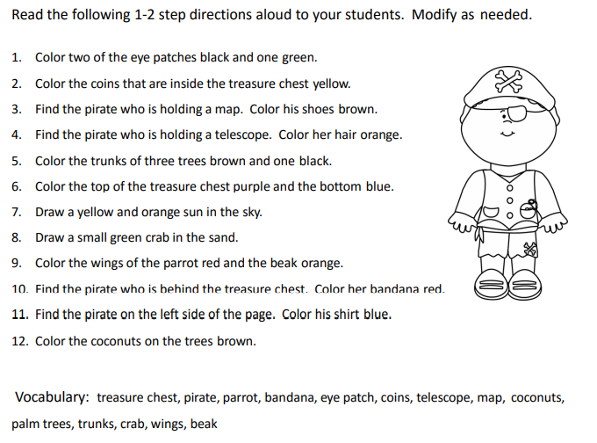

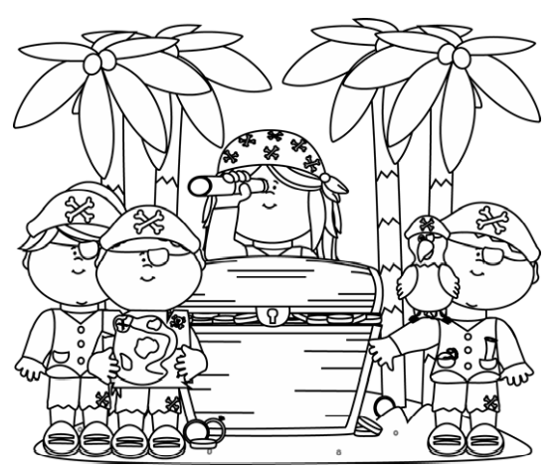

Word Ladders (35 – 38 is for everyone but if you find these easy, also do 39-40)

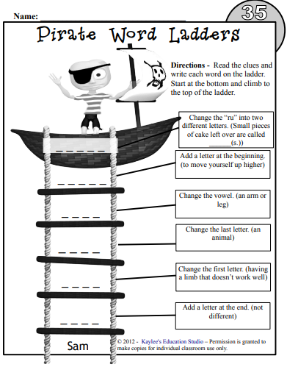

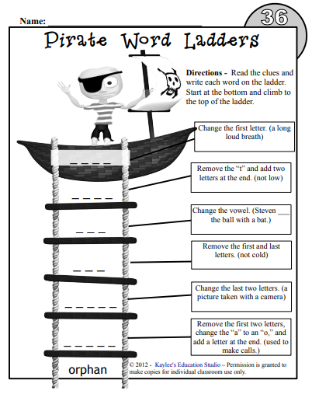

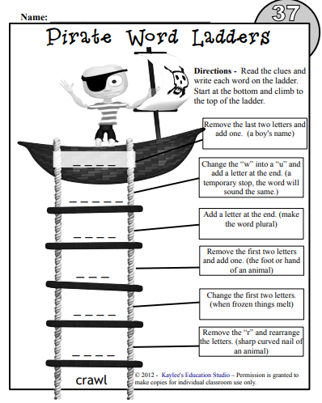

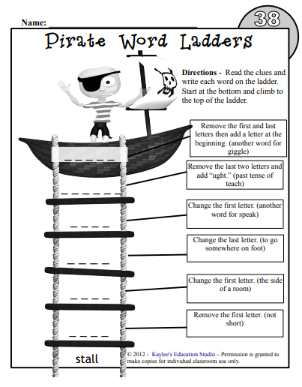

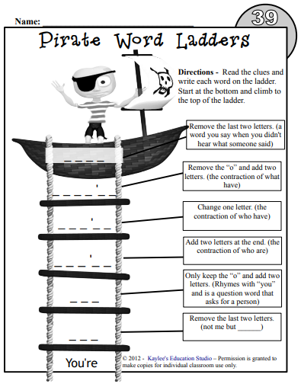

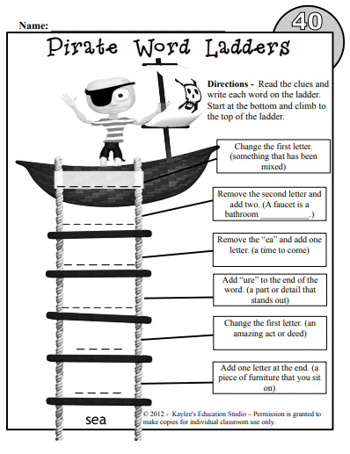

I Want To Be a Pirate Poem and activities
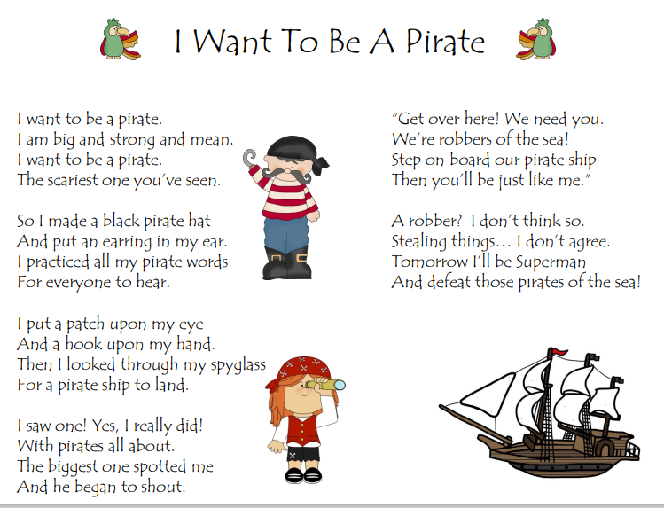

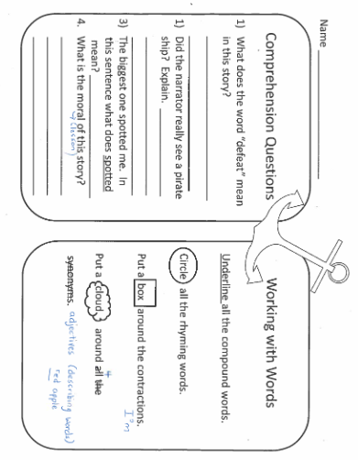

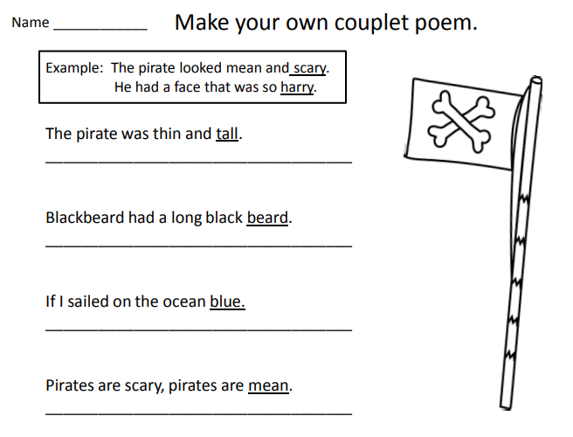

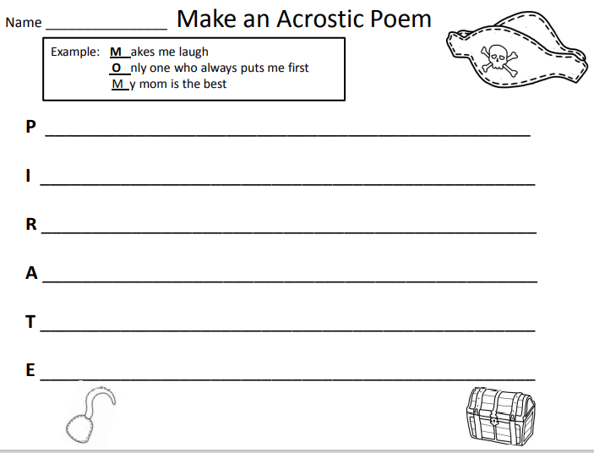

Non-fiction passage about Parrots/questions
Vocabulary and pictures to read—nothing to be completed.

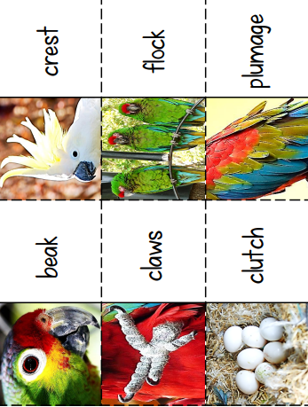

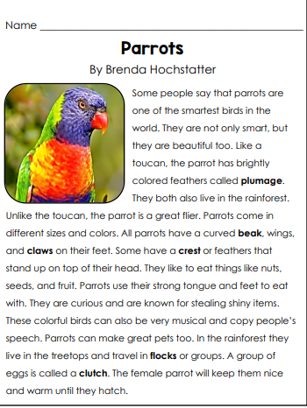

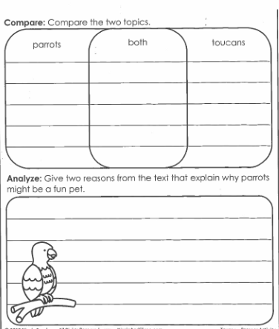

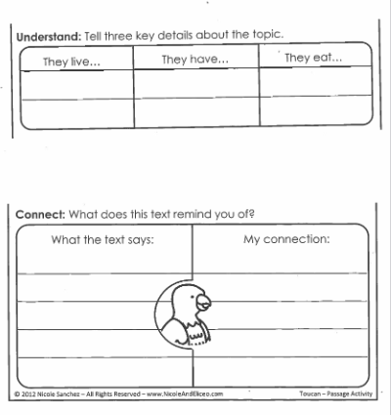

Fiction story about parrots: Polly Parrot Picks a Pirate, Story Train Read Aloud (https://www.youtube.com/watch?v=ZwEHeNyfEsQ)

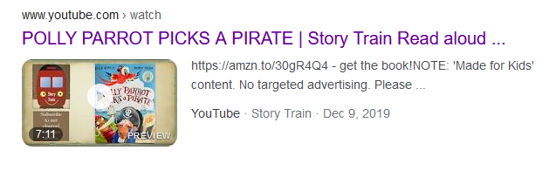

Meredith’s Voyage
