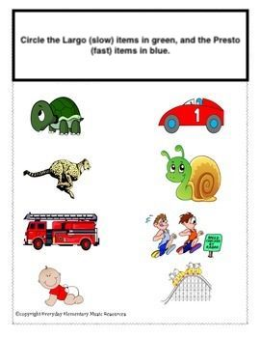

Grade Primary Music Assignment for Ms. Marchand.

Email a list of items that are Largo and Presto to kayla.marchan@gnspes.ca

