Tuesday, January 11 to Friday, January 14, 2022
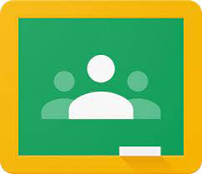
Dear Grade 4 Families,

For the remainder of the week please go to our Google Classroom to find all of the work you are to do each day. Any work and activities will be posted at 9:15 a.m. each day.

Look under each day of the week for that day’s work and activities.

Each day you are to read for 30 minutes. You can read online on EPIC! or you may read your own books from home, or you could do a little of both! That is up to you.

You will also have some writing, word work, AND math to do each day.

Please read all of the directions carefully. **Don’t forget to TURN IN your work in Google Classroom.

If you don’t understand what to do OR you need some help, please come back on our Google Meet link between 1:00 p.m. and 2:00 p.m. to ask any questions. I am there every day at that time.

Ms. Levy
alevy@gnspes.ca

